**Top Down car race starter kit**

Welcome to setup guide for “Top Down cars race starter kit”. In this guide we have included all the instructions to setup this kit for your games and get started with your games.

**Intro:**

We would like to take a moment to introduce you to MAD Entertainment and our projects. We are a small team of passionate gamers and game developers who like to make games. We are a start up in the game development industry and are taking our first steps in this giant world.

We started for developing for web and after a couple of projects we made games for mobile devices. After publishing a couple of games to the Google play store, we are now focusing on making game templates and asset packages that can be used by us and other developers as well.

Following are a few links that will lead you to some of our works.

RGB – A launch ready game template: <https://goo.gl/9jf28E>

Grid – A casual game ready for release: <https://goo.gl/uBFSlz>

Above two game templates are also available on chupamobile.com

Other than these we have two games in Google play store you would like to play.

**Revenge of Ninja:**

<https://play.google.com/store/apps/details?id=com.MADEntertainment.Ninja>

**Tooffers:**

<https://play.google.com/store/apps/details?id=com.MADEntertainment.Dots>

We also have assets available on the Unity Asset store, search MAD Entertainment publisher and you will see all the assets available in the asset store.

Enough about us, now let’s talk about the package and setting up it in your project.

**Package:**

The package includes sprites for all the cars (Police car and ambulance animated) provided by Unlucky Studio. All the cars have their separate prefabs with rigid body and script modified separately.

The package also includes a car controller script to control the car.

A simple “camera follow” script (very basic) and a demo scene with touch control set up.

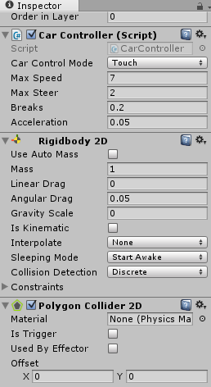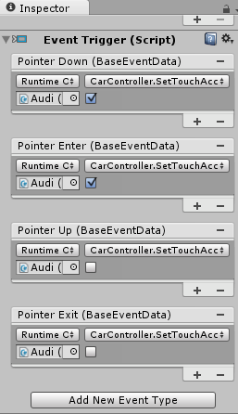

Figure : Screenshot of event triggers for button accelerate forward.

**How to:**

* Simply drag and drop the car prefabs into the scene.
* Change **Car Control Mode** to “touch” for touch input and “Key board” for key board input.
* Script has a few variables set up separately for each vehicle. ‘Max Speed and Acceleration’ are set up higher for light vehicles and lower for heavy vehicles.
* For Key board,
  + Up Arrow: Acceleration while driving forward and brake while driving backwards.
  + Down Arrow: Acceleration while driving backwards and brake while driving forward.
  + Left / Right Arrow: Steer the car.
  + Spacebar: Handbrake.
* For Touch,
  + All the buttons are given on the screen in demo scene.
  + To setup these controls in your own scene, follow the instructions given below.
    - Create button for each control on the screen.
      * Accelerate forward
      * Accelerate Backwards
      * Steer Left
      * Steer Right
      * Hand Brake
    - Add 4 event triggers to each button i.e. Pointer Down, Pointer Up, Pointer Enter and Pointer Exit. (As seen in above screenshot on the right)
    - **Accelerate Forward Button**: Call “SetTouchAccel” function with Boolean set to **true** for **Pointer Down** and **Pointer Enter** and **false** for **Pointer Up** and **Pointer Exit.**
    - **Accelerate Back Button**: Call “SetTouchBack” function with Boolean set to **true** for **Pointer Down** and **Pointer Enter** and **false** for **Pointer Up** and **Pointer Exit.**
    - **Steer Left / Right**: Call “SetSteerLeft” or “SetSteerRight” function with Boolean set to **true** for **Pointer Down** and **Pointer Enter** and **false** for **Pointer Up** and **Pointer Exit.**
    - **Handbrake:** Call “SetTouchBreaks” function with Boolean set to **true** for **Pointer Down** and **Pointer Enter** and **false** for **Pointer Up** and **Pointer Exit.**

Above instructions should be adequate to set up and get going with your projects. In case you run into some trouble feel free to contact us on our email with subject “TopDown Car – [Your name]”, so that we can identify you and can help you ASAP.

We can’t thank you enough for downloading and using the package. Please provide your feedback and suggestions to us so that we can improve our products in future. Please rate our product in the Asset store and mention to others if you liked it.

Follow us on our social channels to know more about our projects and future developments. Here are a few links you can follow to stay updated about us.

Website: <http://www.madentgames.com>

Facebook: <https://www.facebook.com/MADEntertainment97>

Twitter: <https://twitter.com/Monish_MAD>

Happy Gaming..!!

MAD Entertainment